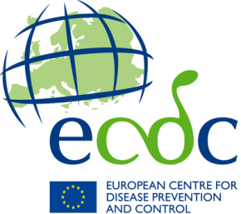
APplication form
Food- and Waterborne Diseases and Zoonoses
Expert Exchange Programme for public health experts in food and waterborne diseases, Legionnaires’ disease and variant Creutzfeldt-Jakob disease (FWDEEP)

Documents to be submitted:
The application should be written in English. For the application to be considered valid, the following documents must be submitted:
- The completed application form;
- Evidence of support from the relevant National Focal Point or National Coordinator;
- Acknowledgement and agreement from hosting institute;
- The draft agenda for the duration of the visit.

Please send the application and required attachments:
To: FWD@ecdc.europa.eu
Subject line: FWDEEP: Application for ECDC FWD Expert Exchange

There are no specific deadlines to submit an application, however, the application needs to be sent to ECDC a minimum of two months before the planned dates of the visit. In order to have the time needed to carry out the practical arrangement, applications for January or February placements must be submitted by 01 October the previous year.
Application Form
First name
Surname
Email address
Nationality
Place of employment
Current role/ Job title
Professional profile | - Epidemiologist  - Microbiologist  - Laboratory technician  - Quality assurance expert  - Bioinformatician  - Other public health expert (please specify):
Area of expertise
Proposed dates of exchange
Proposed hosting site
Applicant type | - Trainee  - Trainer

- Training topics to be covered within scope of the Expert Exchange Programme
(5 points)
- Learning description and objectives to be achieved during exchange visit
(max. 300 words) (20 points)
- How will this exchange benefit and impact your institute and Member State capacity and competence (max. 300 words) (20 points)
- How will this exchange add EU value (max. 300 words) (20 points)

